|  |  |
| --- | --- |
| Team ID | PNT2022TMID38280 |
| Project Name | AI - powered Nutrition Analyzer for Fitness Enthusiasts |

# Model Building

[16]: *# Importing Neccessary Libraries* **import numpy as np** *#used for numerical analysis* **import tensorflow** *#open source used for both ML and DL for computation* **from tensorflow.keras.models import** Sequential *#it is a plain stack of Layers* **from tensorflow.keras import** layers *#A Layer consists of a tensor-in tensor-out*␣ *,*→*computation function*

*#Dense Layer is the regular deeply connected neural network Layer* **from tensorflow.keras.layers import** Dense, Flatten

*#Faltten-used fot flattening the input or change the dimension* **from tensorflow.keras.layers import** Conv2D, MaxPooling2D, Dropout␣ *,*→*#Convolutional layer*

*#MaxPooling2D-for downsampling the image* **from keras.preprocessing.image import** ImageDataGenerator

[17]: model=Sequential()

## 3.0.1 Creating the model

[18]: *# Initializing the CNN* classifier = Sequential()

*# First convolution Layer and pooling* classifier.add(Conv2D(32, (3, 3), input_shape=(64, 64, 3), activation='relu')) classifier.add(MaxPooling2D(pool_size=(2, 2))) *# Second convolution Layer and pooling* classifier.add(Conv2D(32, (3, 3), activation='relu'))

*# input_shape is going to be the pooled feature maps from the previous*␣ *,*→*convolution Layer*

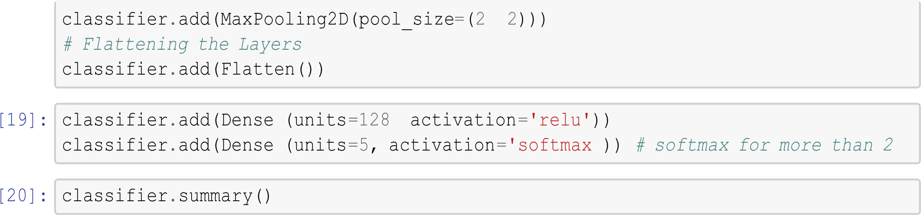

Model: "sequential_1"

_________________________________________________________________

Layer (type) Output Shape Param #

=================================================================

|  |  |
| --- | --- |
| conv2d (Conv2D) (None, 62, 62, 32) | 896 |
| max_pooling2d (MaxPooling2D (None, 31,  31, 32) ) | 0 |
| conv2d_1 (Conv2D) (None, 29, 29, 32) | 9248 |
| max_pooling2d_1 (MaxPooling (None, 14, 14,  32) 2D) | 0 |
| flatten (Flatten) (None, 6272) | 0 |
| dense (Dense) (None, 128) | 802944 |
| dense_1 (Dense) (None, 5) | 645 |

=================================================================

Total params: 813,733

Trainable params: 813,733

Non-trainable params: 0

_________________________________________________________________

[21]: classifier.compile(optimizer='adam', loss='sparse_categorical_crossentropy',␣ *,*→metrics=['accuracy'])

## 3.1 Fitting the model

[22]: classifier.fit_generator( generator=x_train, steps_per_epoch = len(x_train),␣

*,*→epochs=20, validation_data=x_test, validation_steps = len(x_test)) *# No of*␣ *,*→*images in test set*

Epoch 1/20

/usr/local/lib/python3.7/dist-packages/ipykernel_launcher.py:1: UserWarning: `Model.fit_generator` is deprecated and will be removed in a future version.

Please use `Model.fit`, which supports generators. """Entry point for launching an IPython kernel.

526/526 [==============================] - 15s 13ms/step - loss:

0.1652 - accuracy: 0.9391 - val_loss: 0.1162 - val_accuracy: 0.9621

Epoch 2/20

526/526 [==============================] - 6s 12ms/step - loss:

0.0592 - accuracy: 0.9817 - val_loss: 0.0045 - val_accuracy: 1.0000

Epoch 3/20

526/526 [==============================] - 6s 12ms/step - loss:

4.5107e-04 - accuracy: 1.0000 - val_loss: 0.0203 - val_accuracy: 0.9896

Epoch 4/20

526/526 [==============================] - 6s 12ms/step - loss:

1.8523e-04 - accuracy: 1.0000 - val_loss: 0.0052 - val_accuracy: 1.0000

Epoch 5/20

526/526 [==============================] - 6s 12ms/step - loss:

8.9034e-05 - accuracy: 1.0000 - val_loss: 0.0113 - val_accuracy: 0.9905

Epoch 6/20

526/526 [==============================] - 6s 12ms/step - loss:

5.6083e-05 - accuracy: 1.0000 - val_loss: 0.0066 - val_accuracy: 1.0000

Epoch 7/20

526/526 [==============================] - 8s 14ms/step - loss:

3.1644e-05 - accuracy: 1.0000 - val_loss: 0.0128 - val_accuracy: 0.9905

Epoch 8/20

526/526 [==============================] - 6s 12ms/step - loss:

2.3077e-05 - accuracy: 1.0000 - val_loss: 0.0188 - val_accuracy: 0.9896

Epoch 9/20

526/526 [==============================] - 6s 12ms/step - loss:

2.8951e-05 - accuracy: 1.0000 - val_loss: 0.0113 - val_accuracy: 0.9915

Epoch 10/20

526/526 [==============================] - 7s 13ms/step - loss:

1.6114e-05 accuracy: 1.0000 - val_loss: 0.0256 - val_accuracy:

0.9867

Epoch 11/20

526/526 [==============================] - 7s 13ms/step - loss:

1.4261e-05 accuracy: 1.0000 - val_loss: 0.0124 - val_accuracy:

0.9905

Epoch 12/20

526/526 [==============================] - 7s 13ms/step - loss:

5.8428e-06 accuracy: 1.0000 - val_loss: 0.0147 - val_accuracy:

0.9905

Epoch 13/20

526/526 [==============================] - 7s 13ms/step - loss:

4.0379e-06 accuracy: 1.0000 - val_loss: 0.0121 - val_accuracy:

0.9915

Epoch 14/20

526/526 [==============================] - 7s 13ms/step - loss:

4.0424e-06 - accuracy: 1.0000 - val_loss: 0.0118 - val_accuracy: 0.9915

Epoch 15/20

526/526 [==============================] - 7s 13ms/step - loss:

2.0868e-06 accuracy: 1.0000 - val_loss: 0.0140 - val_accuracy:

0.9905

Epoch 16/20

526/526 [==============================] - 7s 13ms/step - loss:

1.3716e-06 - accuracy: 1.0000 - val_loss: 0.0019 - val_accuracy: 1.0000

Epoch 17/20

526/526 [==============================] - 8s 14ms/step - loss:

1.5067e-06 - accuracy: 1.0000 - val_loss: 0.0177 - val_accuracy: 0.9896

Epoch 18/20

526/526 [==============================] - 7s 13ms/step - loss:

1.2072e-06 - accuracy: 1.0000 - val_loss: 0.0248 - val_accuracy: 0.9877

Epoch 19/20

526/526 [==============================] - 7s 13ms/step - loss:

7.0966e-07 - accuracy: 1.0000 - val_loss: 0.0147 - val_accuracy: 0.9905

Epoch 20/20

526/526 [==============================] - 7s 13ms/step - loss:

0.0510 accuracy: 0.9890 - val_loss: 5.1513e-04 - val_accuracy:

1.0000

[22]: <keras.callbacks.History at 0x7f4ed0fb4c50>



Test the model

[24]: *### Predicting our results* **from tensorflow.keras.preprocessing import** image **from tensorflow.keras.models**

grayscale=**False**,␣

**import**

load_model

*#from*

*keras.preprocessing import image*

model

=

load_model(

"nutrition.h5"

)

*#Loading the model*

*for testing*

[25]:

i

mg

=

image

.

load_img(

'/content/TEST_SET/APPLES/151_100.jpg'

,

*,*

→

target_size

=

(

64

,

64

))

*#Loading of the image*

*#img =*

*image.load_img('/content/dataset/Testing/bears/k4*

*(88).*

*,*

→

*jpeg',target_size=(64,64))*

x

=

image

.

img_to_array(img)

*#image to array*

x

=

np

.

expand_dims(x,axis

=0

)

*#changing the shape*

*#pred = model.predict_classes(x) #predicting*

*the classes*

*#pred*

pred

=

np

.

argmax(model

.

predict(x))

print(pred, model.predict(x))

1/1 [==============================] - 0s 96ms/step

1/1 [==============================] - 0s 18ms/step

0 [[1. 0. 0. 0. 0.]]

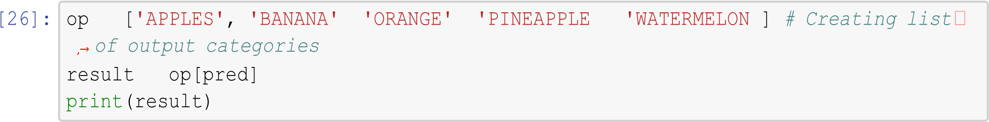

APPLES

[29]: img =

image.load_img('/content/TEST_SET/WATERMELON/143_100.jpg',␣

*,*→grayscale=**False**, target_size= (64,64)) *#Loading of the image #img =*

*image.load_img('/content/dataset/Testing/bears/k4*

*(88).*

*,*

→

*jpeg',target_size=(64,64))*

x

=

image

.

img_to_array(img)

*#image to array*

x

=

np

.

expand_dims(x,axis

=0

)

*#changing the shape*

*#pred = model.predict_classes(x) #predicting*

*the*

*classes*

*#pred* pred = np.argmax(model.predict(x )) print(pred, model.predict(x))

1/1 [==============================] - 0s 17ms/step

1/1 [==============================] - 0s 17ms/step

4 [[0. 0. 0. 0. 1.]]

